**Step 1: Create a New User in Azure Active Directory**

1. **Log in to the** [**Azure Portal**](https://portal.azure.com/).
2. In the left-hand menu, search for and select **Azure Active Directory**.
3. In the **Azure Active Directory** pane, select **Users** from the left-hand menu.
4. Click **+ New user** at the top.
5. Fill in the details for the new user:
   * **User name**: Enter the username (test).
   * **Name**: Enter the user's full name.
   * **Password**: Either auto-generate a password or create one manually. The user will need this to sign in initially.
   * You can configure other settings as required.
6. After filling in the necessary details, click **Create**.

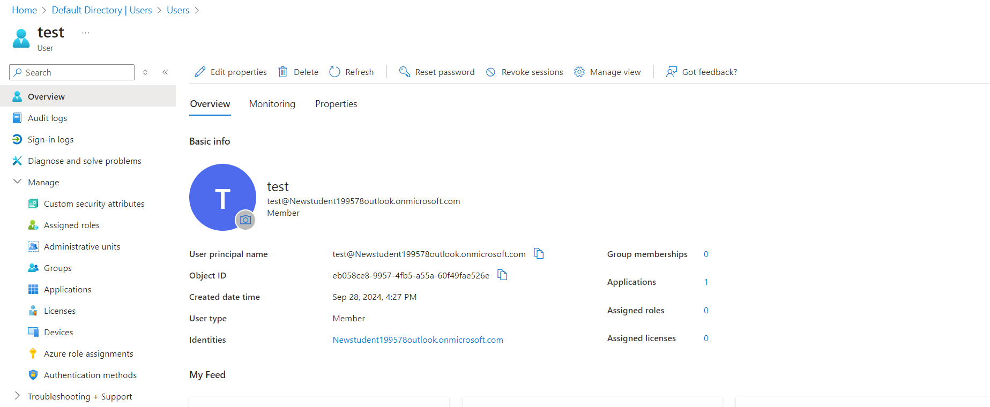

**Step 2: Assign the Custom Role to the New User**

1. After creating the user, navigate to the **Access control (IAM)** section of the **resource**, **resource group**, or **subscription** where the role should be assigned (follow the same steps as in the custom role creation process).
2. In the **Access control (IAM)** pane, click on **+ Add**, then select **Add role assignment**.
3. In the **Role** dropdown, search for and select the custom role you created (View access).

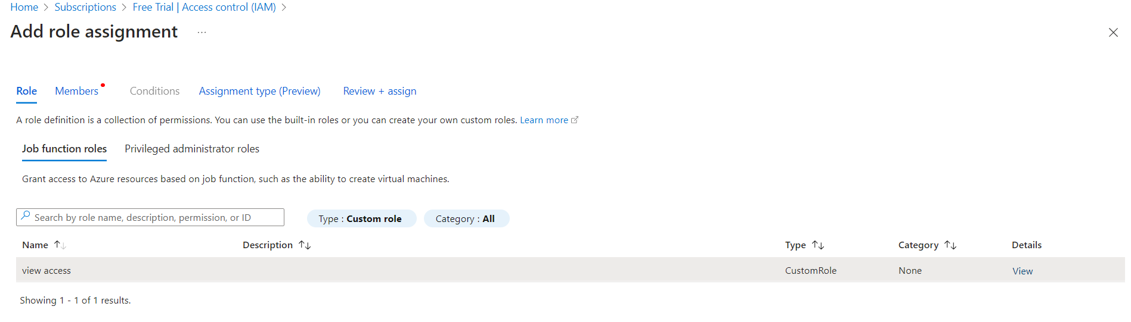

1. In the **Assign access to** dropdown, select **User, group, or service principal**.
2. In the **Select** field, search for the newly created user (test) and select it.

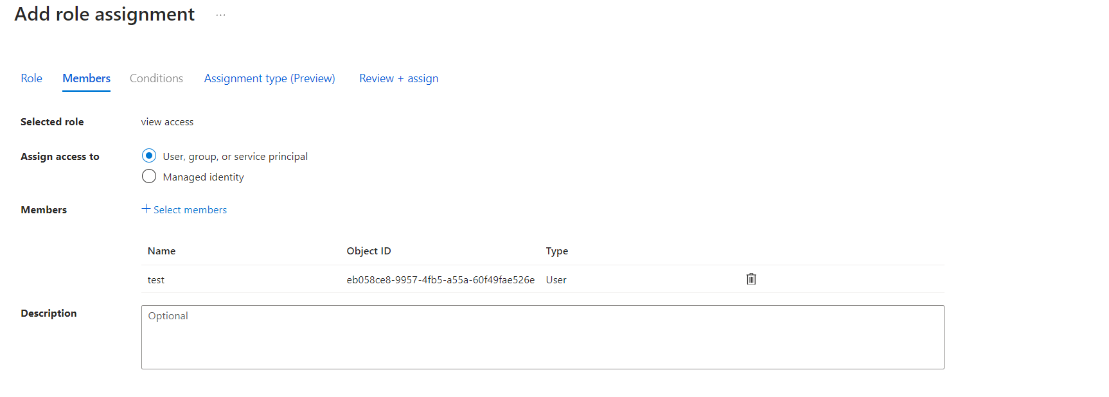

1. Click **Save** to assign the role to the user.

